Solution Design Document

QAD Download File

**Process Name**: QAD Download File

**Prepared by**: Netlink

**Date Prepared**: 07-02-2020

**Last Updated**: 07-02-2020

**Version**: 1.0

TABLE OF CONTENTS

1 DOCUMENT HISTORY 3

2 DEVELOPERS 3

3 GLOSSARY OF TERMS 3

4 DATABASE 3

5 SQL QUERIES 3

6 DETAILED PROCESS FLOW 4

7 FLOW CHART 6

8 EXCEPTIONS 7

9 PROCESS CONFIGURATION 7

# DOCUMENT HISTORY

|  |  |  |  |
| --- | --- | --- | --- |
| **Version** | **Description** | **Date** | **Author** |
| 1.0 | Initial Draft | 07-02-2020 | Bharti |

# DEVELOPERS

|  |  |
| --- | --- |
| **Name** | **Package Version** |
| Bharti |  |

# GLOSSARY OF TERMS

The following table includes definitions for any abbreviations or notations that are used in the document:

|  |  |
| --- | --- |
| **Term** | **Definition** |
| RPA | Robotic Process Automation |

# 6 DETAILED PROCESS FLOW

Step 1 – Robot will login to QAD with valid credentials.

Step 2 – Robot will read all the menu options from the input file.

Step 3 – Menu option is entered in QAD and following input is given.

|  |  |  |
| --- | --- | --- |
| **Menu** | **Menu Option** | **Field - Input** |
| Allocation | 18.22.9 | * Effective date = today – 1 * Update = yes * Output- 32prn |

Step 4 – The 32prn printer window will pop up and following actions takes place

* If pop up is successful, Send to Notepad option is clicked.
* If pop up is not successful, transaction is ended.

Step 5 – The Notepad Window opens and following actions takes place.

* If window opens is successful, file is saved to particular path.

# 7 FLOW CHART

Connect to QAD System

Disconnect from QAD

Save the file to the requied path

Click on “Send to Notepad”

Notepad window opened

Enter Menu Option and Input field

Read the Menu Option from Input File

32prn Printer Windw exist

j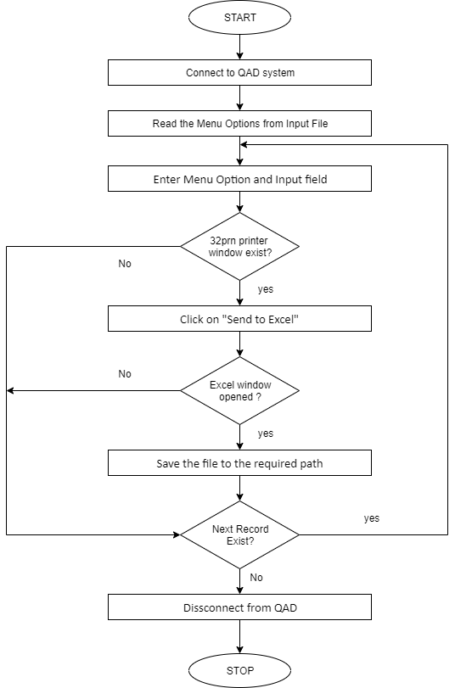

# 8 EXCEPTIONS

1. **Application Exception**

|  |  |  |
| --- | --- | --- |
| **SL NO** | **EXCEPTION** |  |
| 1 | Database connectivity issues | Connection has to be stable |
| 2 | QAD connectivity issues | Connection has to be stable |

1. **Business Exception**

|  |  |  |
| --- | --- | --- |
| **SL NO** | **FIELD** | **EXCEPTION** |
| 1 | Output | Output device entered is not a defined printer |
| 2 | Batch ID | Batch control record does not exist for this Batch ID |
| 3 | From Date/To Date(invalid month) | Month of a date should be from 1 to 12 |
| 4 | From Date/To Date (Invalid day) | Day in a month is invalid |
| 5 | From Date/To Date (Invalid year) | Invalid period/year |
| 6 | Year | Invalid Format – Year should be greater than 2000 |

# 9 PROCESS CONFIGURATION

1 - “Config.xlsx” Contains all the Config data like Email credentials etc. used in the Process.